Practical No 09

VIII. Resources required (Additional)
→ If any web resources required.

Resources used (Additional)
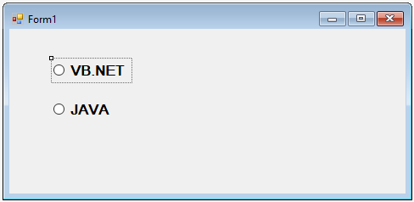→ https://docs.microsoft.com/en- us/dotnet/api/system.windows.forms.checkbox?view=netframework-4.7.2
→ https://docs.microsoft.com/en- us/dotnet/api/system.windows.forms.radiobutton?view=netframework-4.7.2

Program Code
Write a program to demonstrate the use of CheckBox and RadioButton.
- Code to check Radio Buttons State

Public Class Form1
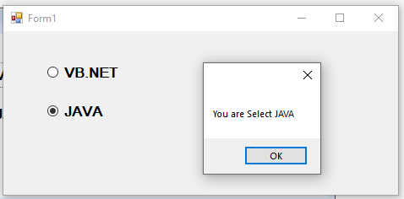Private Sub RadioButton1_CheckedChanged(sender As Object, e As EventArgs) Handles RadioButton1.CheckedChanged
If (RadioButton1.Checked = True) Then MessageBox.Show("You are Select VB.NET")
End If End Sub
Private Sub RadioButton2_CheckedChanged(sender As Object, e As EventArgs) Handles RadioButton2.CheckedChanged
If (RadioButton2.Checked = True) Then MessageBox.Show("You are Select JAVA")
End If End Sub
End Class

OUTPUT :

Code to display message when the checkbox is checked -

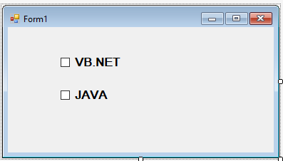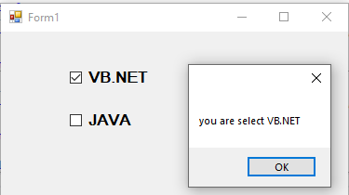

Public Class Form1
Private Sub CheckBox1_CheckedChanged(sender As Object, e As EventArgs) Handles CheckBox1.CheckedChanged
MessageBox.Show("you are select VB.NET") End Sub

Private Sub CheckBox2_CheckedChanged(sender As Object, e As EventArgs) Handles CheckBox2.CheckedChanged
MessageBox.Show("you are select JAVA") End Sub
End Class
OUTPUT :

- Practical related Questions
  - Write the program using RadioButton to change the bulb state ON/OFF.
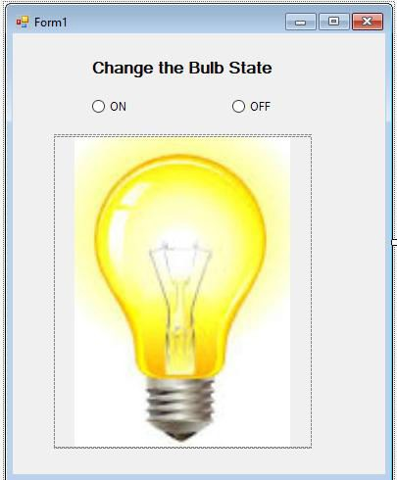➢

Public Class Form1
Private Sub RadioButton1_CheckedChanged(sender As Object, e As EventArgs) Handles RadioButton1.CheckedChanged
PictureBox2.Show() PictureBox1.Hide()
End Sub

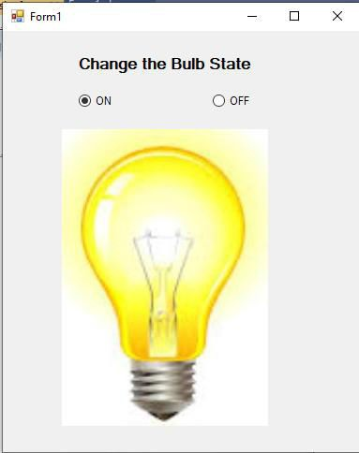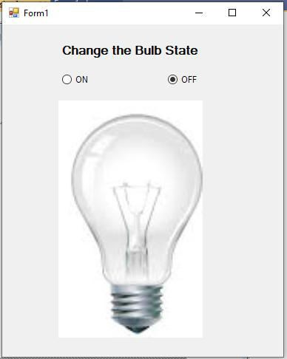Private Sub RadioButton2_CheckedChanged(sender As Object, e As EventArgs) Handles RadioButton2.CheckedChanged

PictureBox1.Show() PictureBox2.Hide()
End Sub End Class

OUTPUT:

  - Differentiate between RadioButton and CheckBox controls.
- In a checkbox group, a user can select more than one option. Each checkbox operates individually, so a user can toggle each response "Checked" and "Not Checked."
- Radio buttons, however, operate as a group and provide mutually exclusive selection values. A user can select only one option in a radio button group.

rcise
  - 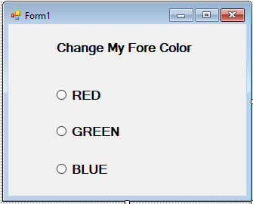Write a program to change the ForeColor of the text in Label using different RadioButtons such Red, Green, Blue.
➢

Public Class Form1
Private Sub RadioButton1_CheckedChanged(sender As Object, e As EventArgs) Handles RadioButton1.CheckedChanged
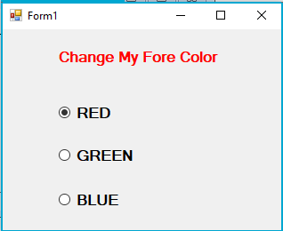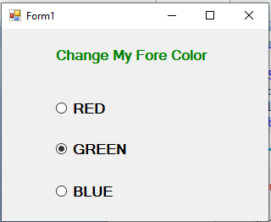Label1.ForeColor = Color.Red End Sub

Private Sub RadioButton2_CheckedChanged(sender As Object, e As EventArgs) Handles RadioButton2.CheckedChanged
Label1.ForeColor = Color.Green End Sub

Private Sub RadioButton3_CheckedChanged(sender As Object, e As EventArgs) Handles RadioButton3.CheckedChanged
Label1.ForeColor = Color.Blue End Sub
End Class

